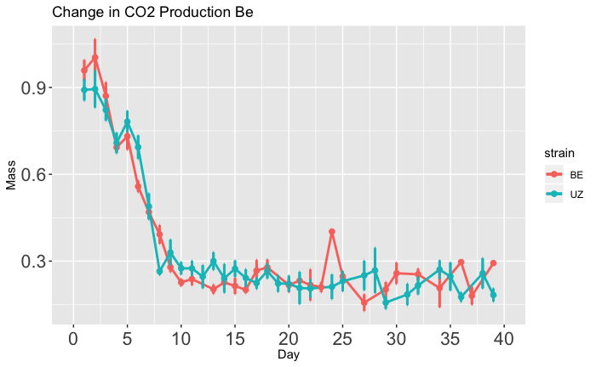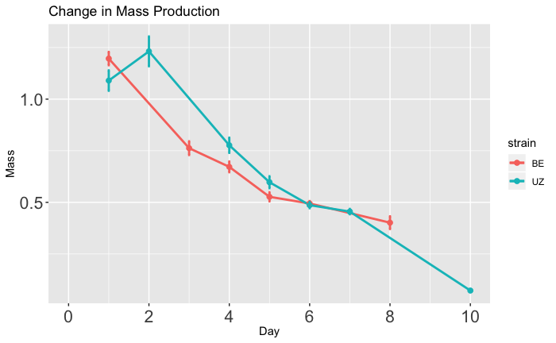

1.0

0.5

0 2 4 6 8 10

Time (days)

0.9

0.6

0.3

0 5 10 15 20 25 30 35 40

Time (days)

B

A

CO2  Production (µ/g/min)

(Diapause)

CO2  Production (µ/g/min)

(Non-diapause)

Long-Diapause

Short-Diapause

**\***

Long-Diapause

Short-Diapause

**\***